Observations on [OP-642](https://theodyssey.atlassian.net/browse/OP-642)

1. For the existing production media service "odysseymedia1" CDN is enabled. The endpoint that is configured for "odysseymedia1" is "odysseymedia1.streaming.mediaservices.windows.net".

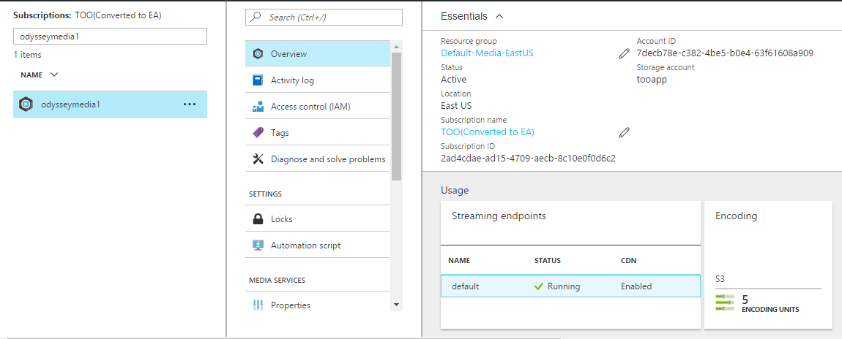

As per below link it looks like Azure Media service users Verizon CDN.

<https://docs.microsoft.com/en-us/azure/media-services/media-services-portal-manage-streaming-endpoints>

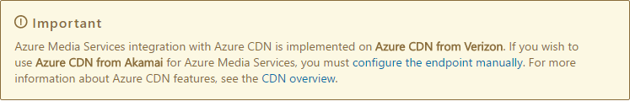

1. We have 3 CDN profiles as can be seen in below screenshots.
   1. CDN [Standard Akamai] does not have any endpoints and not in use
   2. DefaultProfile [Standard Verizon] has 4 endpoints
   3. Static [Premium Verizon] has 1 endpoint

None of the above are being use for azure media service and only default CDN is used.

